WIREFRAME

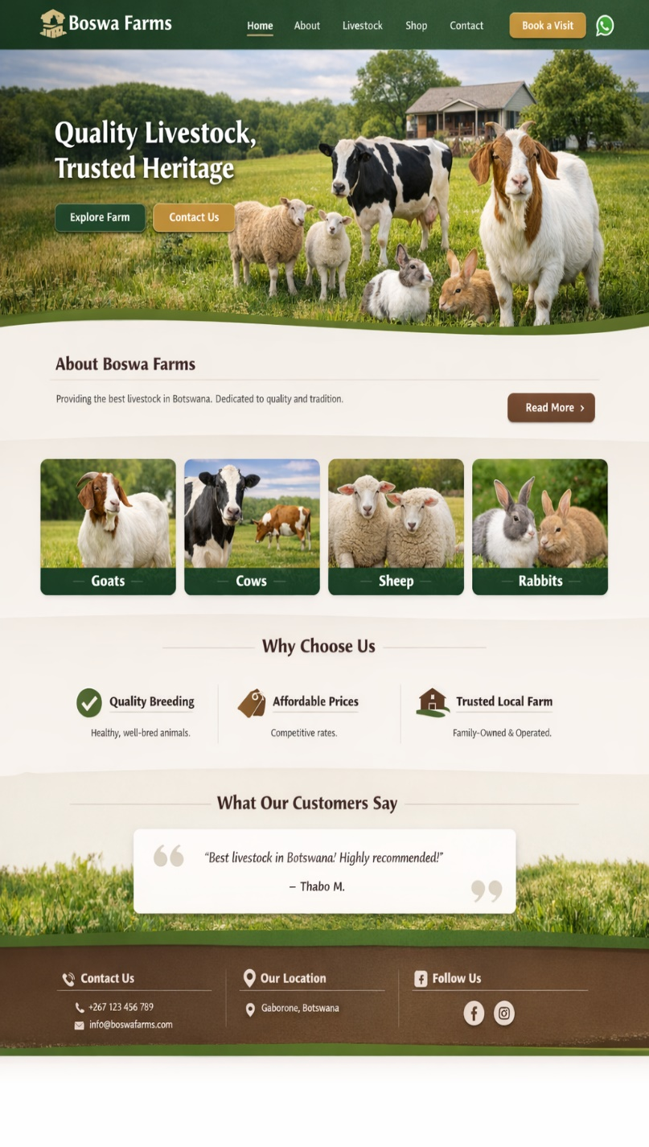
Testimonials
About Us
Products\ Categories
Footer, Contact info, Location, Pages
Headline, Navigation &main image

WIREFRAME

